## THEORY OF COMPUTATIONS LAB QUESTIONS USING SIMULATION

D.NAGOORVALI

REGNO:192110338

12. Design DFA using simulator to accept the input string “a” ,”ac”,and ”bac”

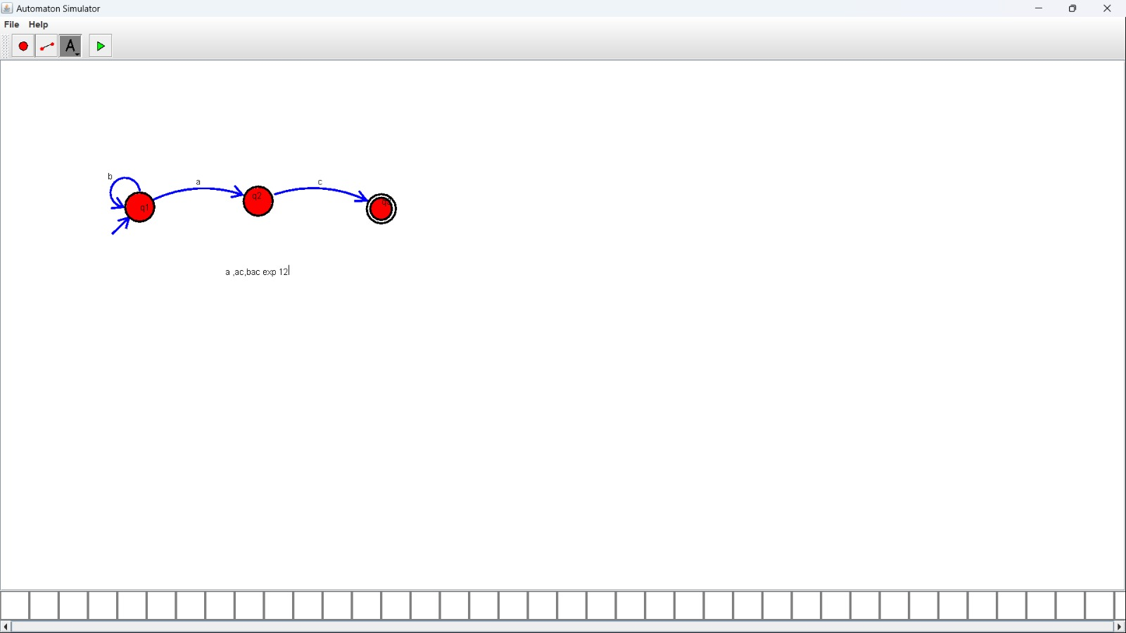

13. Design PDA using simulator to accept the input string aabb

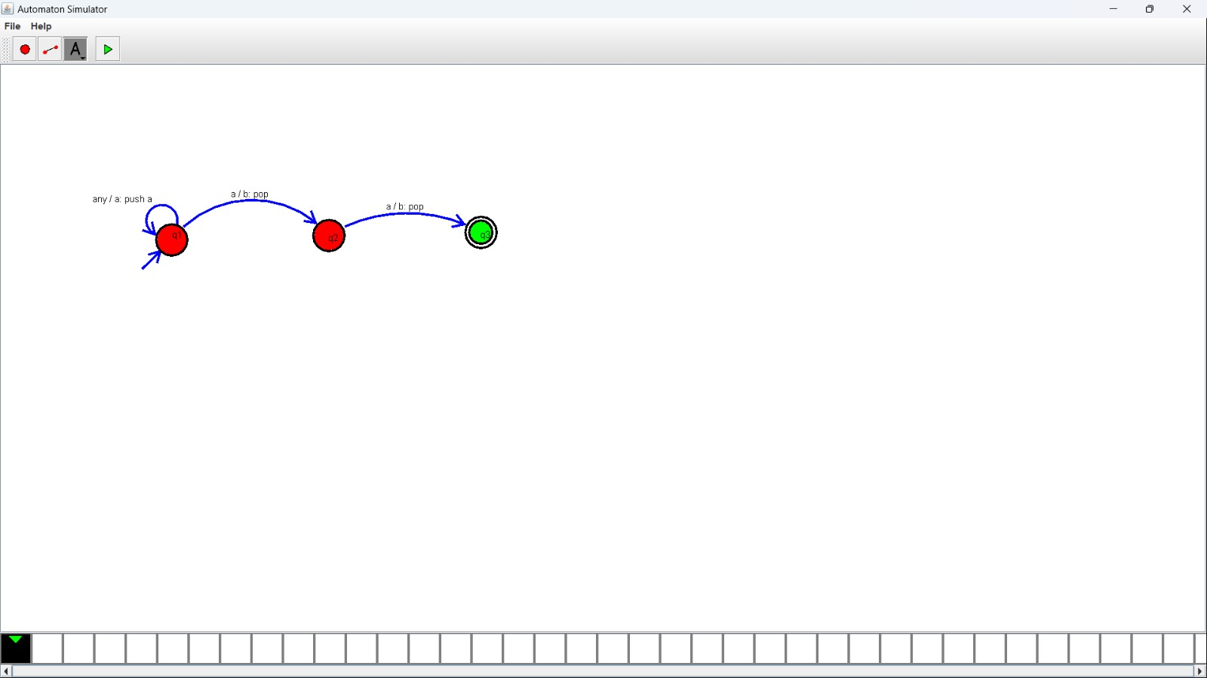

14. Design PDA using simulator to accept the input string anb2n

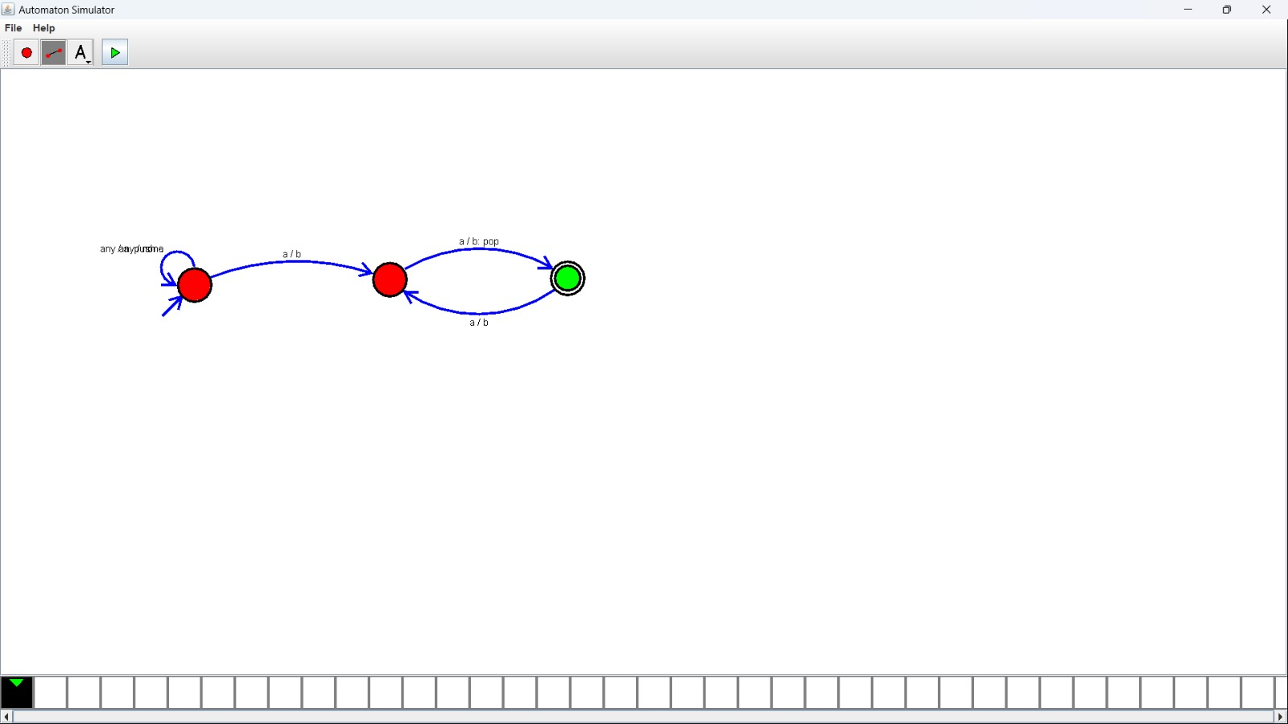

15. Design TM using simulator to accept the input string anbn

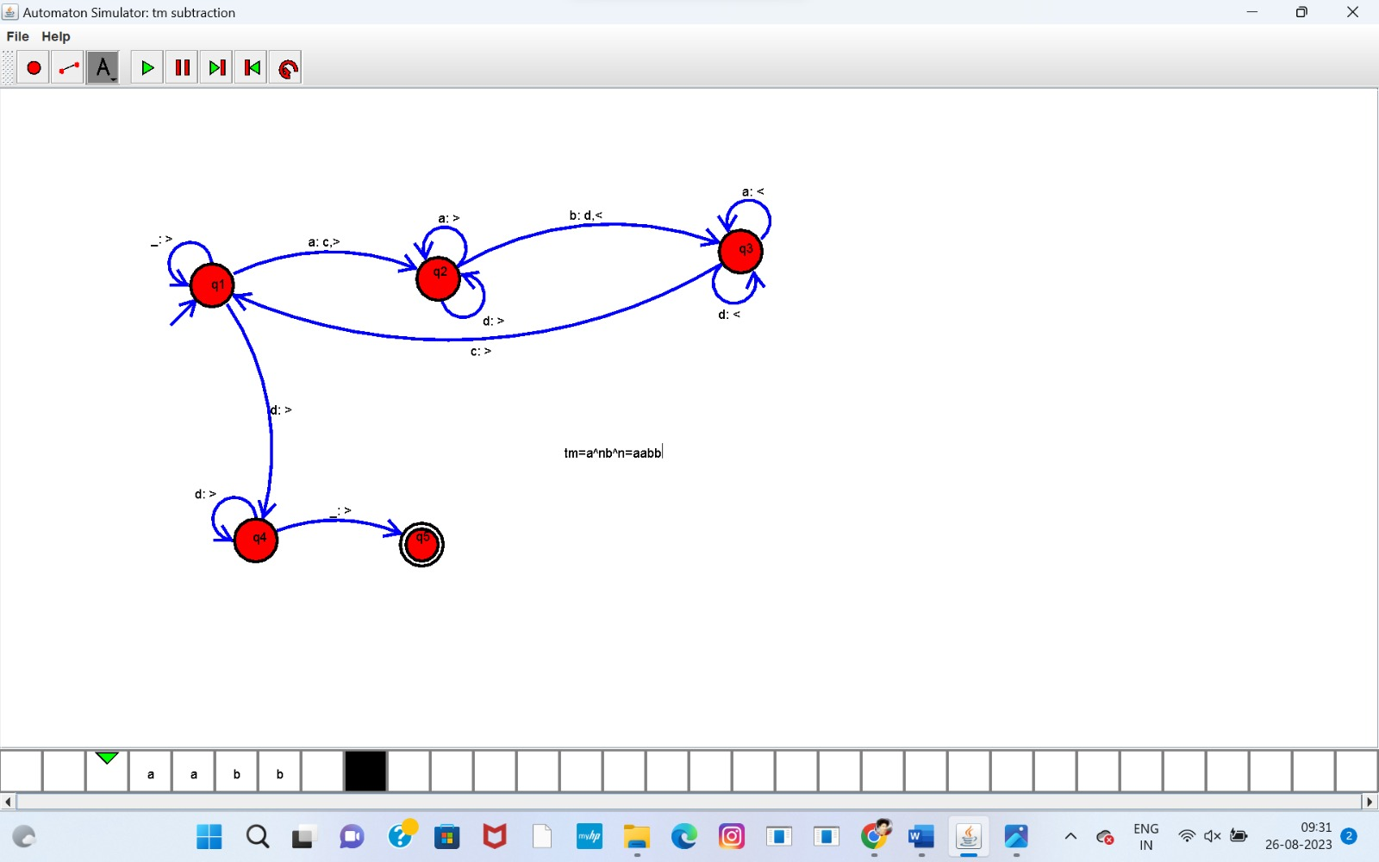

16. Design TM using simulator to accept the input string anb2n

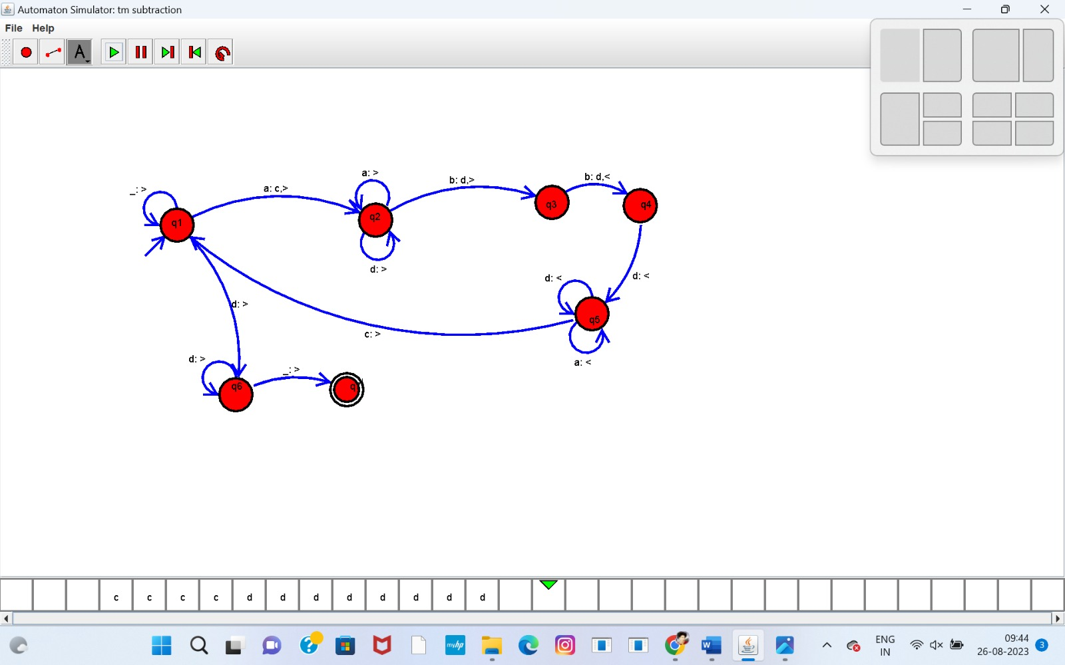

17 Design TM using simulator to accept the input string Palindrome ababa

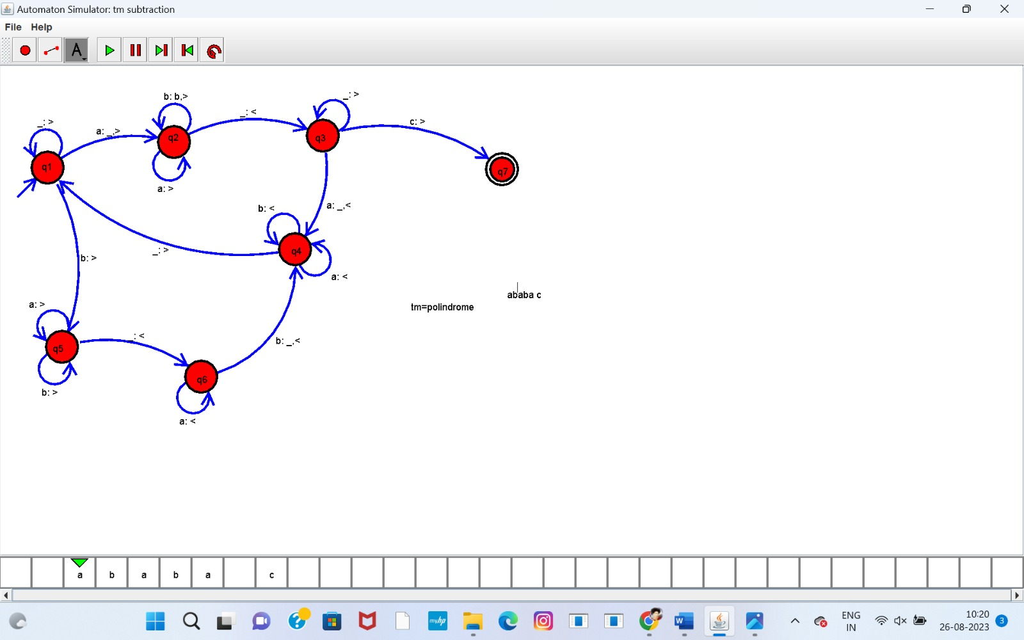

18. Design TM using simulator to accept the input string ww

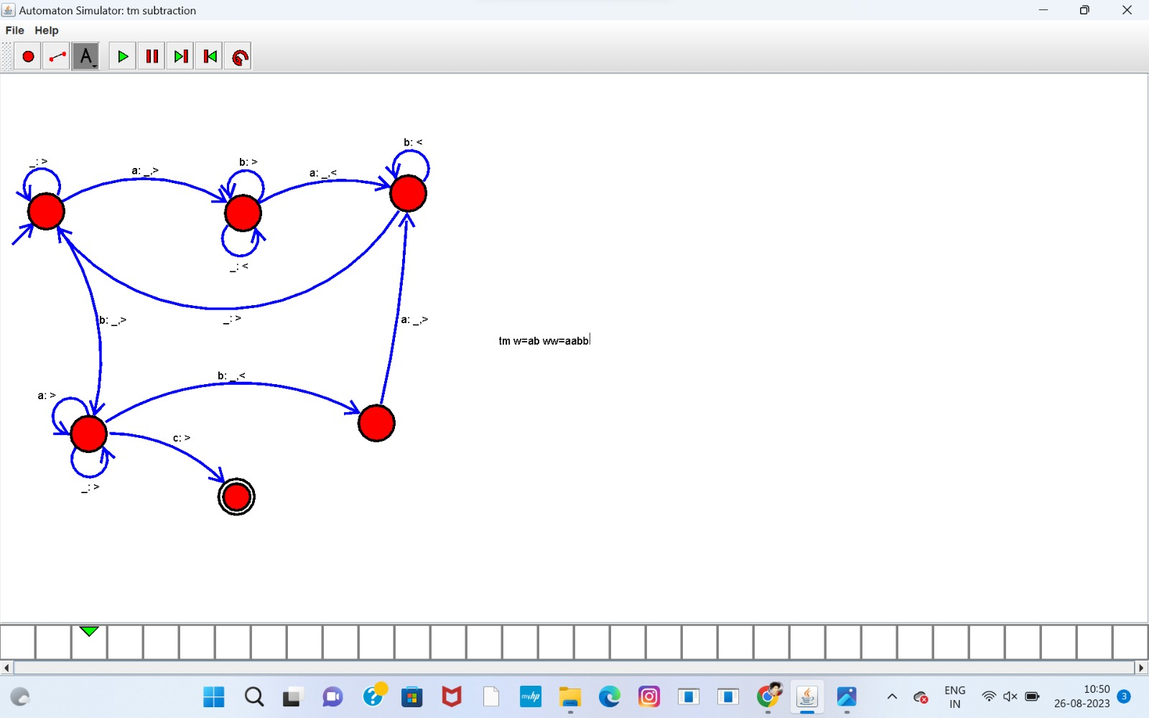

19. Design TM using simulator to perform addition of ‘aa’ and ‘aaa’

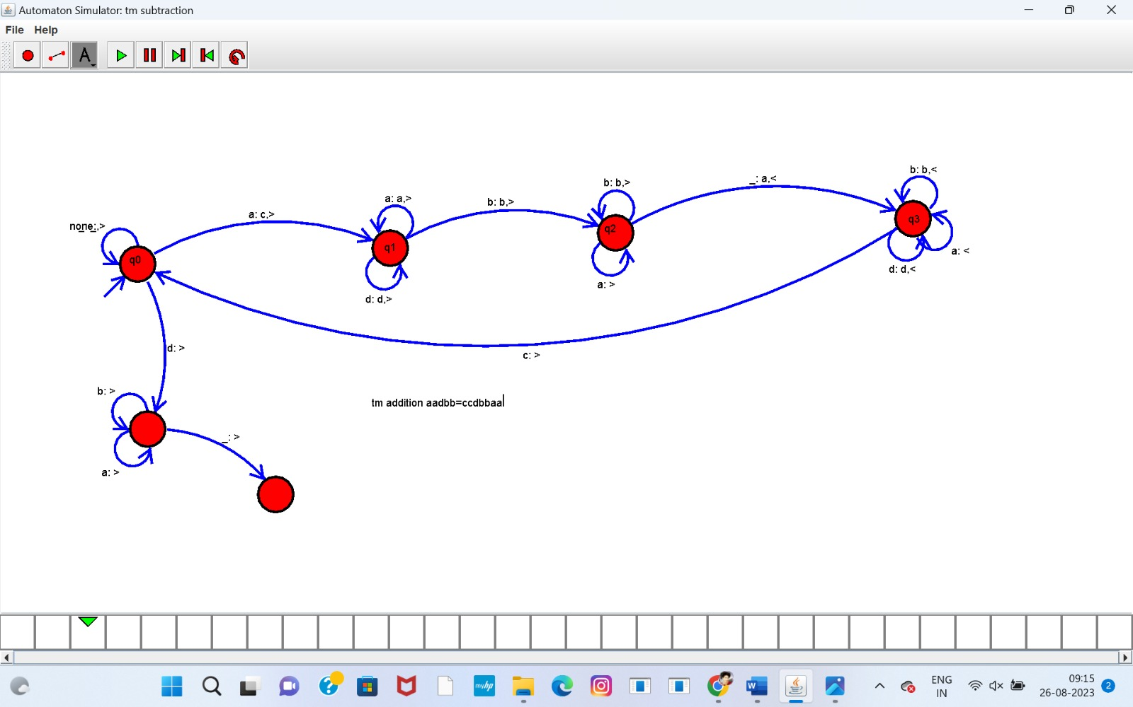

20. Design TM using simulator to perform subtraction of aaa-aa

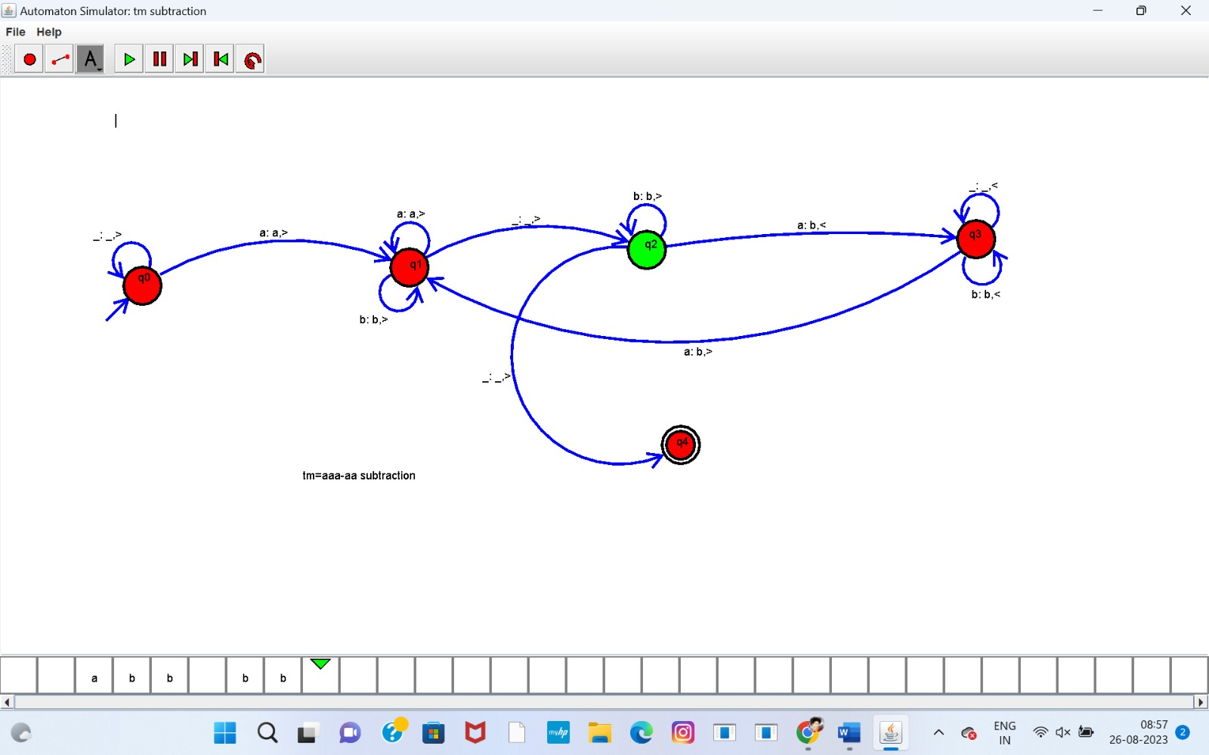

21.Design DFA using simulator to accept even number of a’s

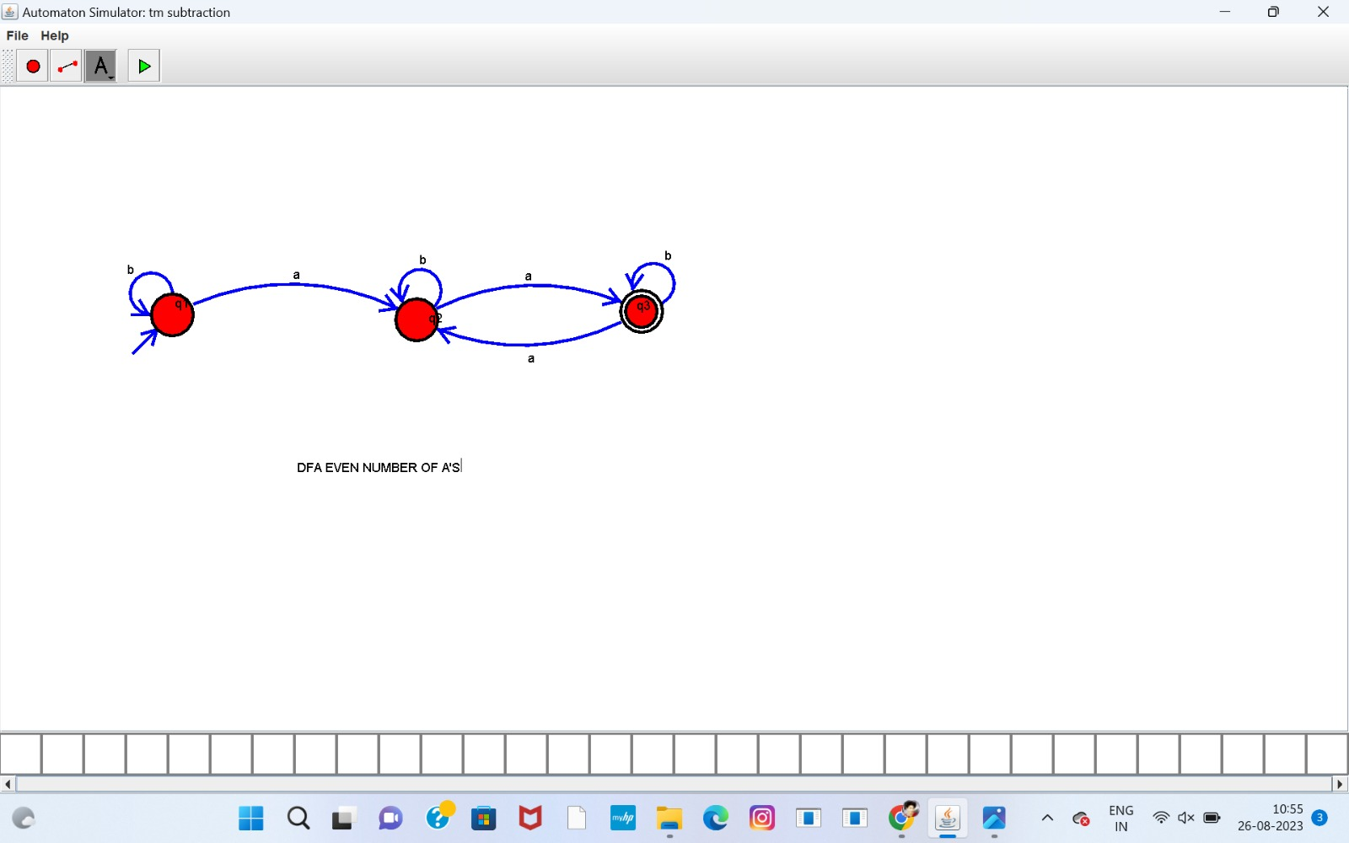

22.Design DFA using simulator to accept odd number of a’s

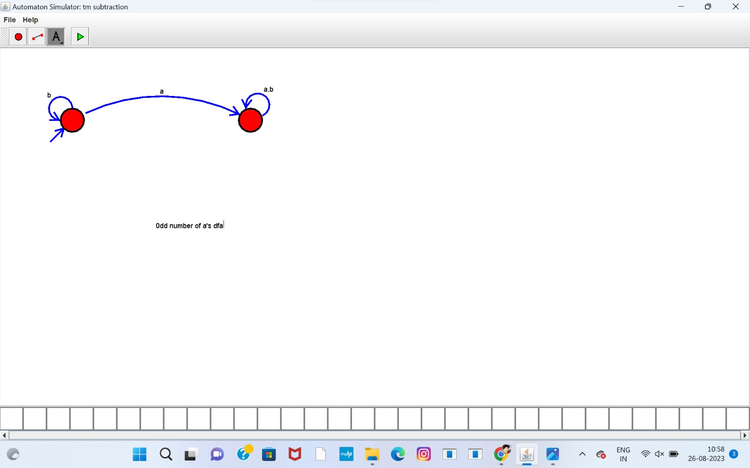

23.Design DFA using simulator to accept the string the end with ab over set {a,b)

W= aaabab

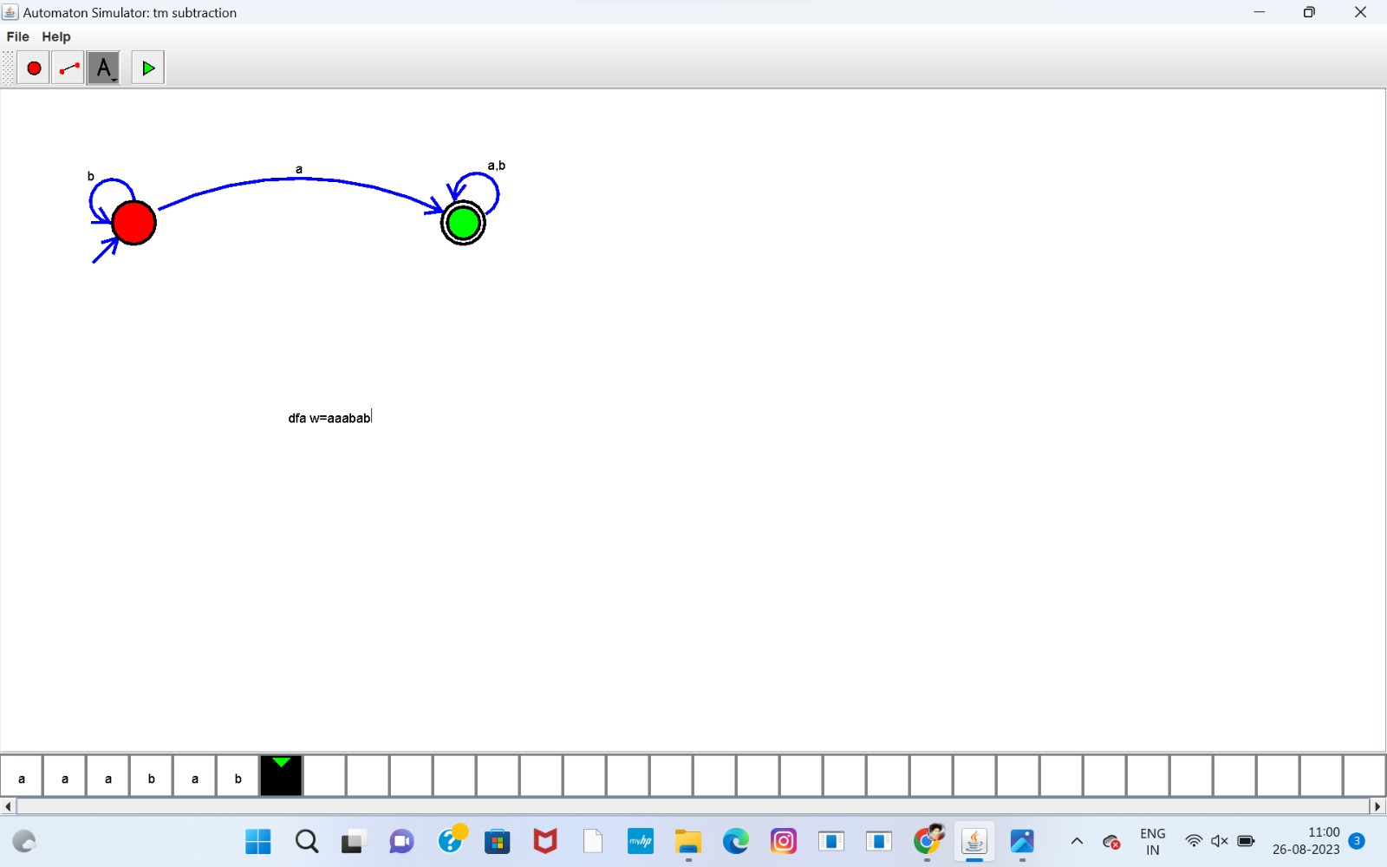

24 Design DFA using simulator to accept the string having ‘ab’ as substring over the set {a,b}

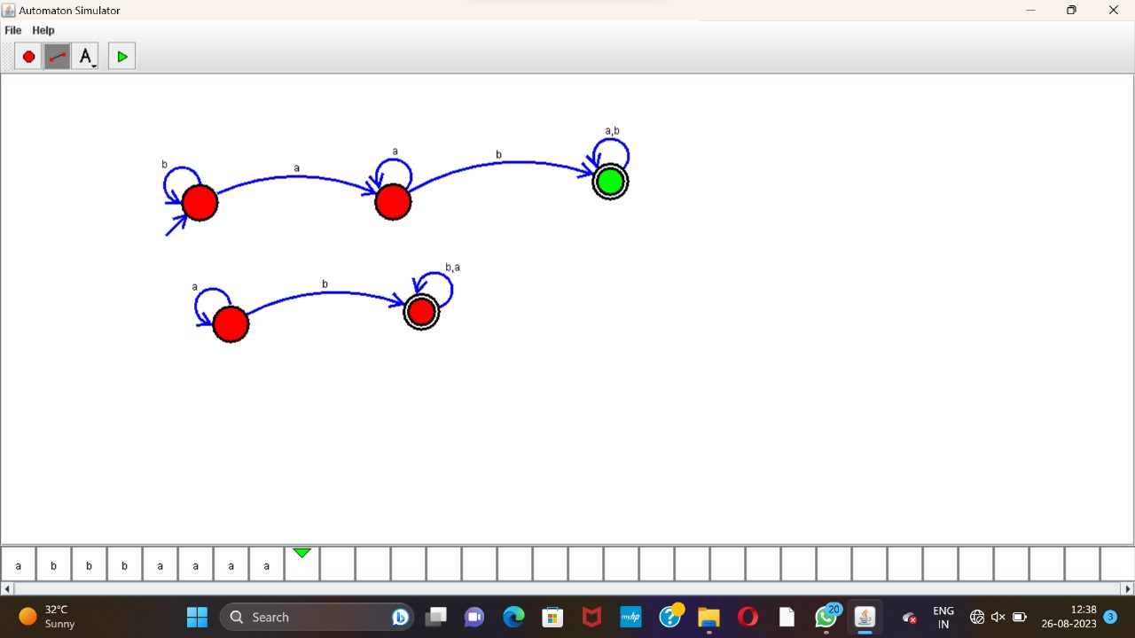

25. Design DFA using simulator to accept the string start with a or b over the set {a,b}

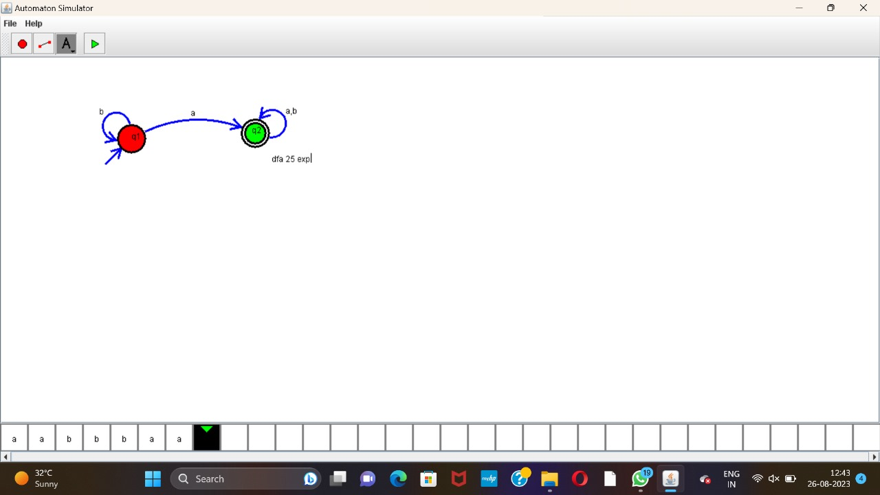

26 Design TM using simulator to accept the input string Palindrome bbabb

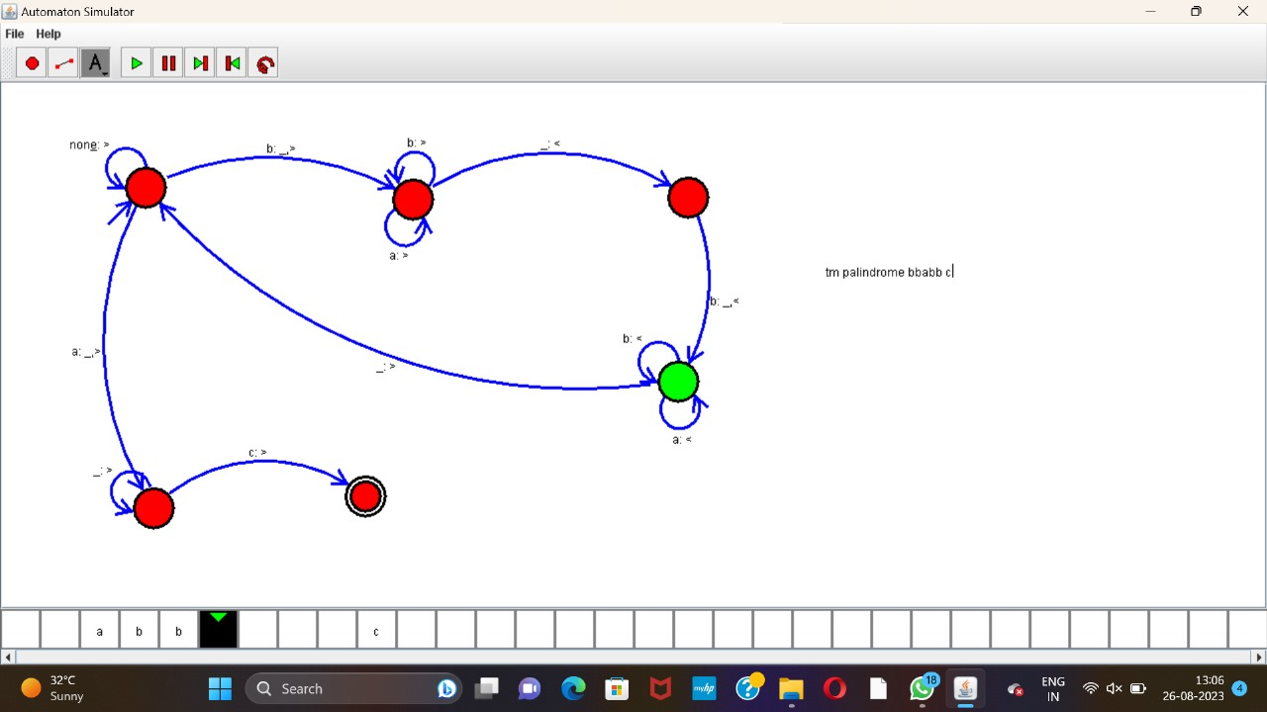

27. Design TM using simulator to accept the input string wcw

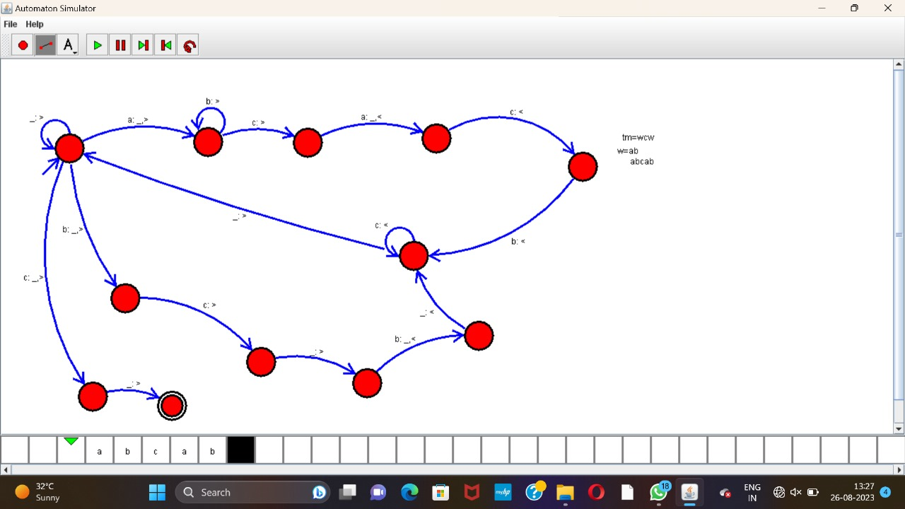

28. Design DFA using simulator to accept the string the end with ab over set {a,b)W= abbaabab

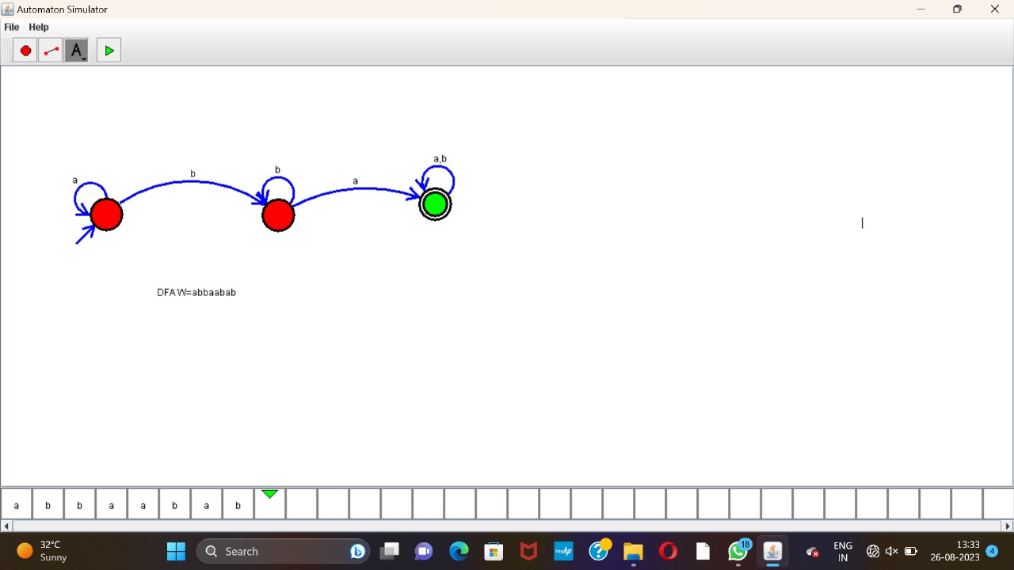

29. Design DFA using simulator to accept the input string “bc” ,”c”,and ”bcaaa”.

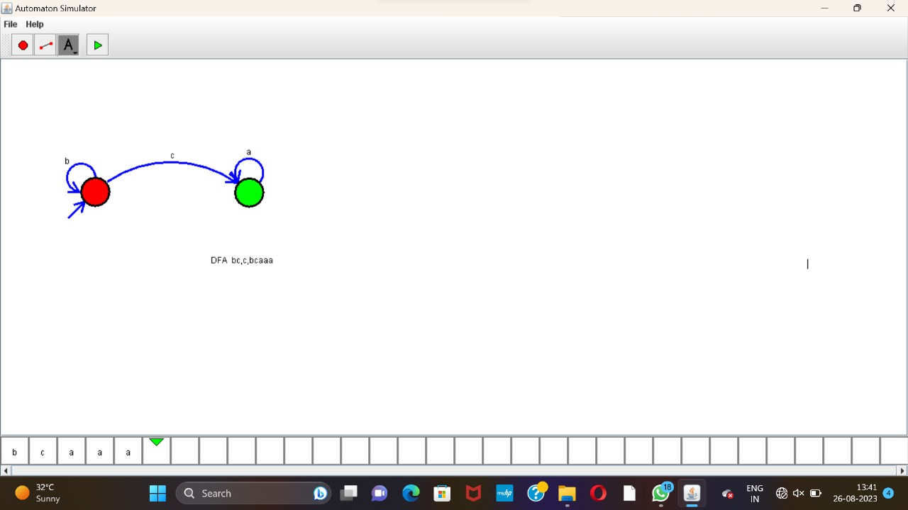

30. Design NFA to accept any number of a’s where input={a,b}.

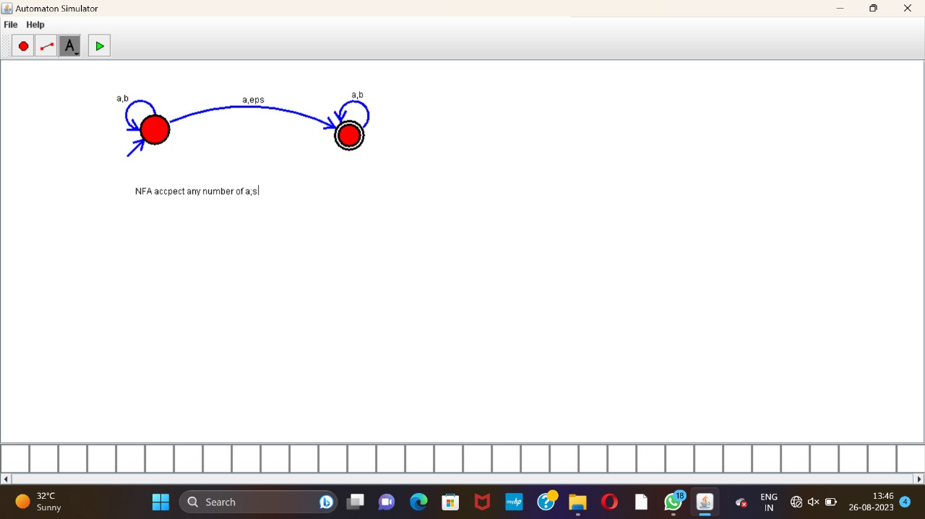

31. Design PDA using simulator to accept the input string anbn

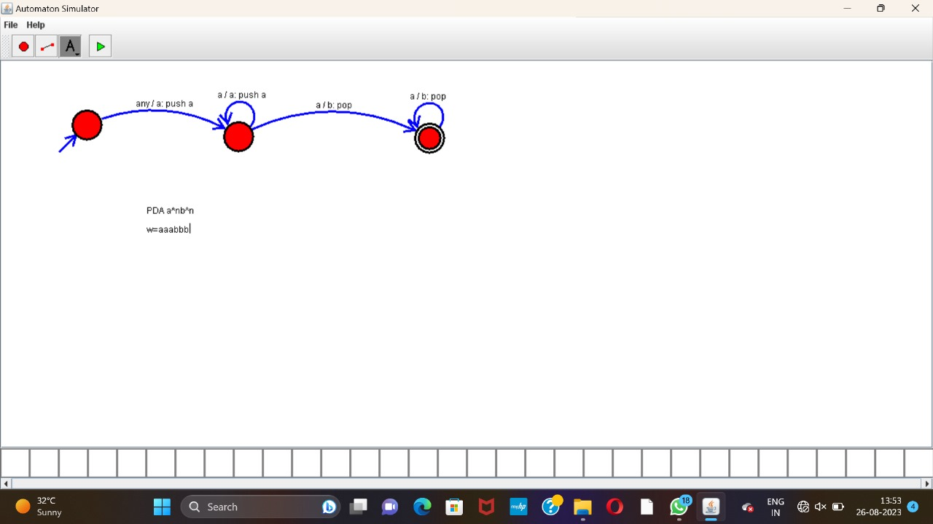

32. Design TM using simulator to perform string comparison where w={aba aba}

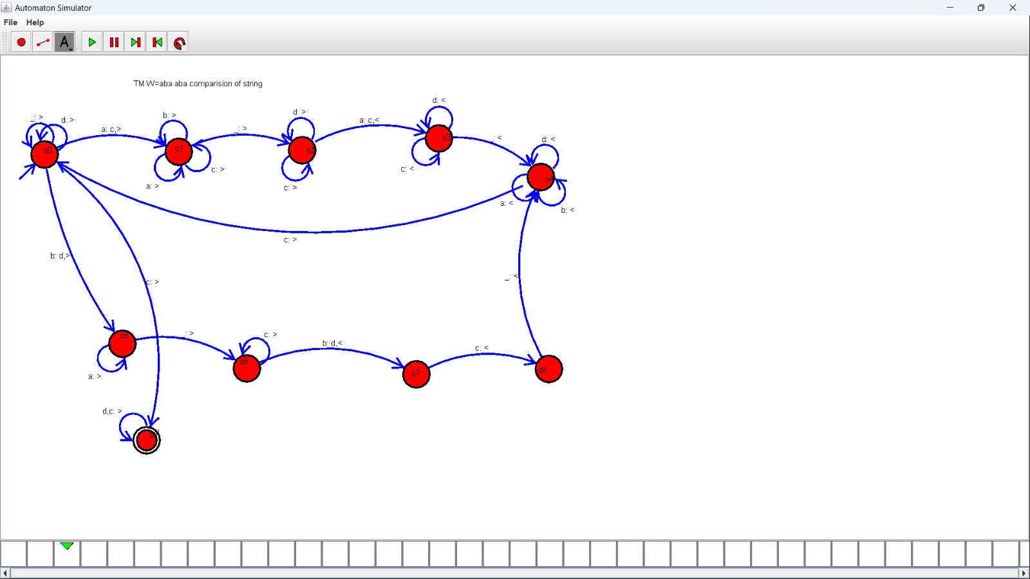

33. Design DFA using simulator to accept the string having ‘abc’ as substring over the set {a,b,c}

.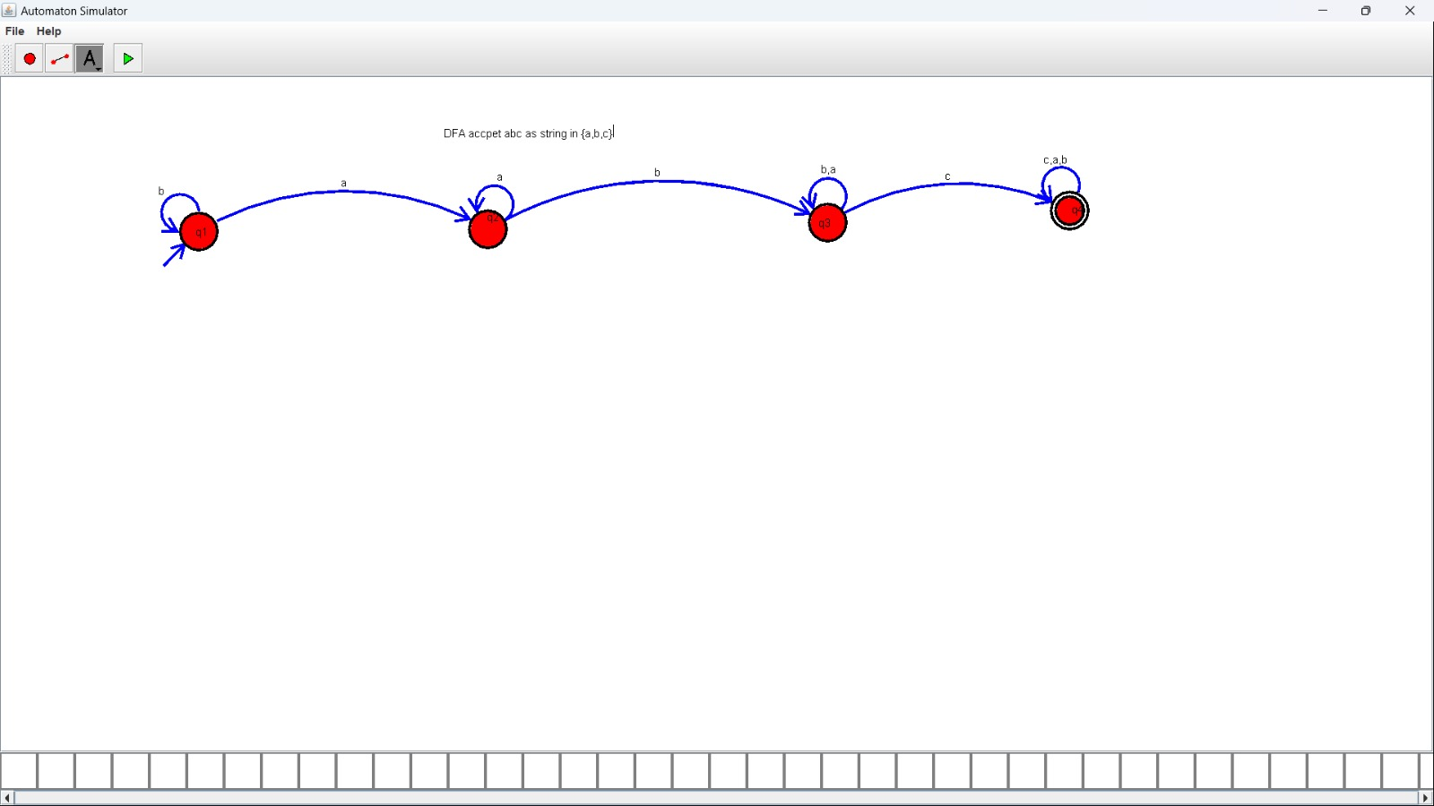

34. Design DFA using simulator to accept even number of c’s over the set {a,b,

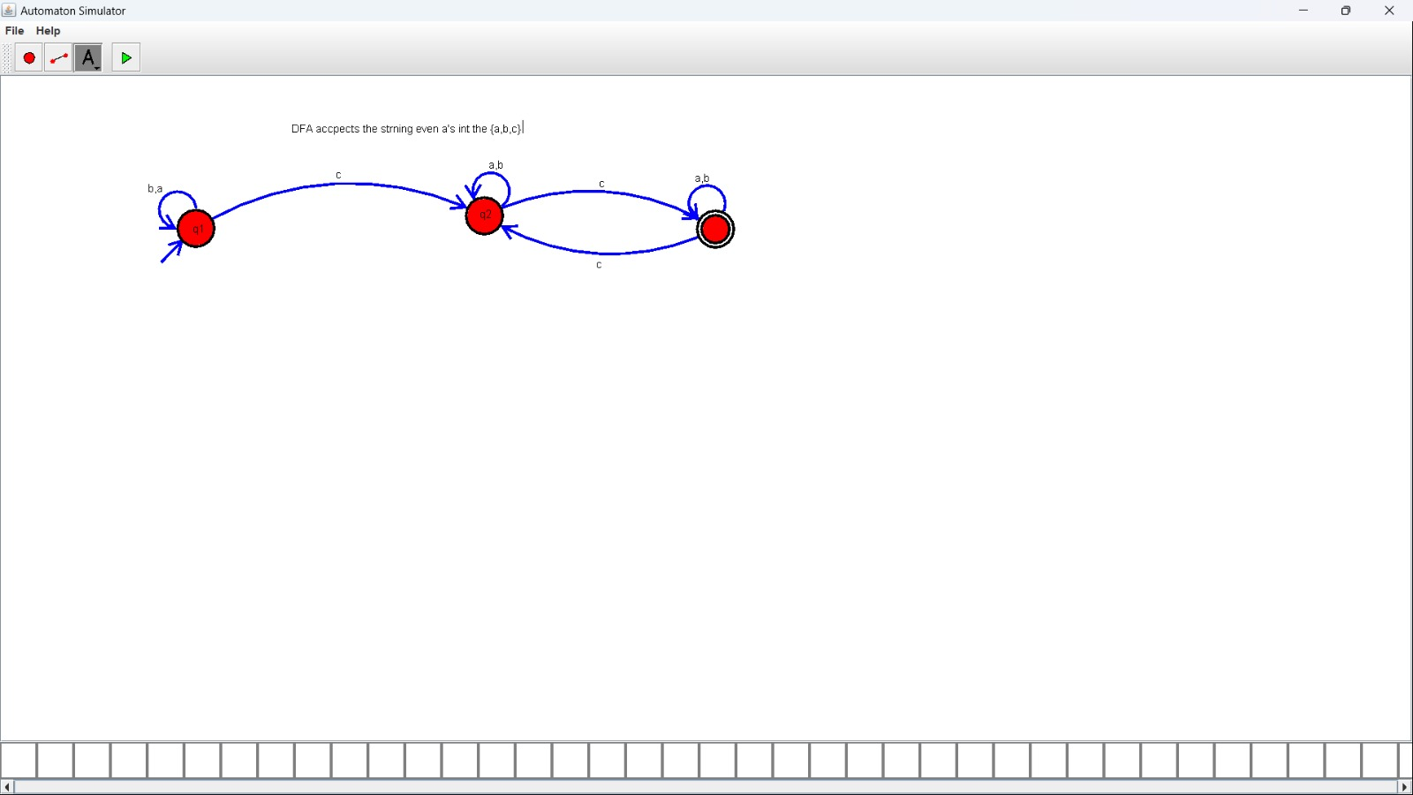

35. Design DFA using simulator to accept strings in which a’s always appear tripled over input {a,b}

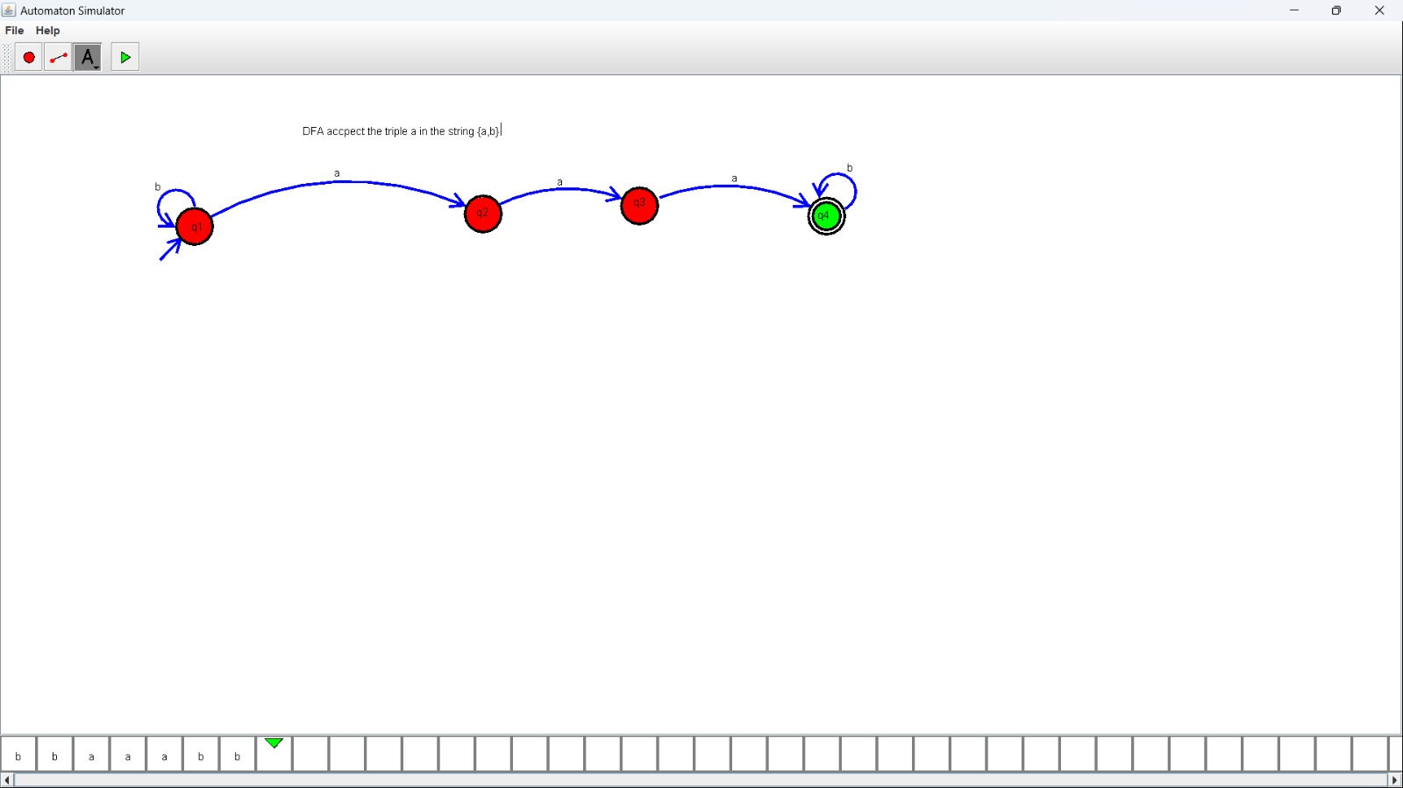

36. Design NFA using simulator to accept the string the start with a and end with b over set {a,b} and check W= abaab is accepted or not.

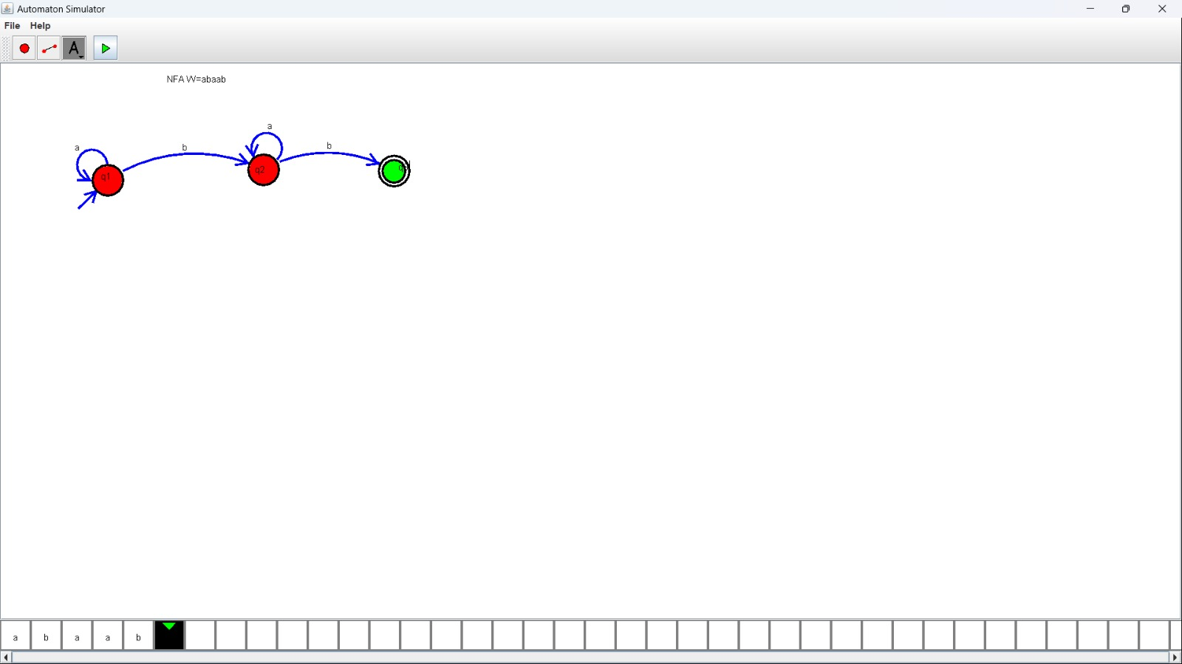

37. Design NFA using simulator to accept the string that start and end with different symbols over the input {a,b}.

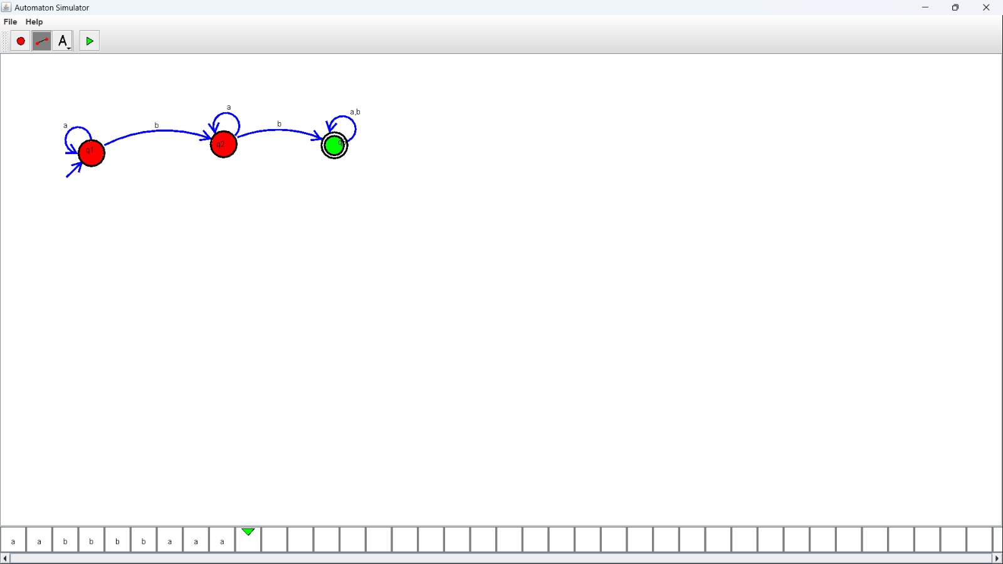

38. Design NFA using simulator to accept the input string “bbc” ,”c”,and ”bcaaa”.

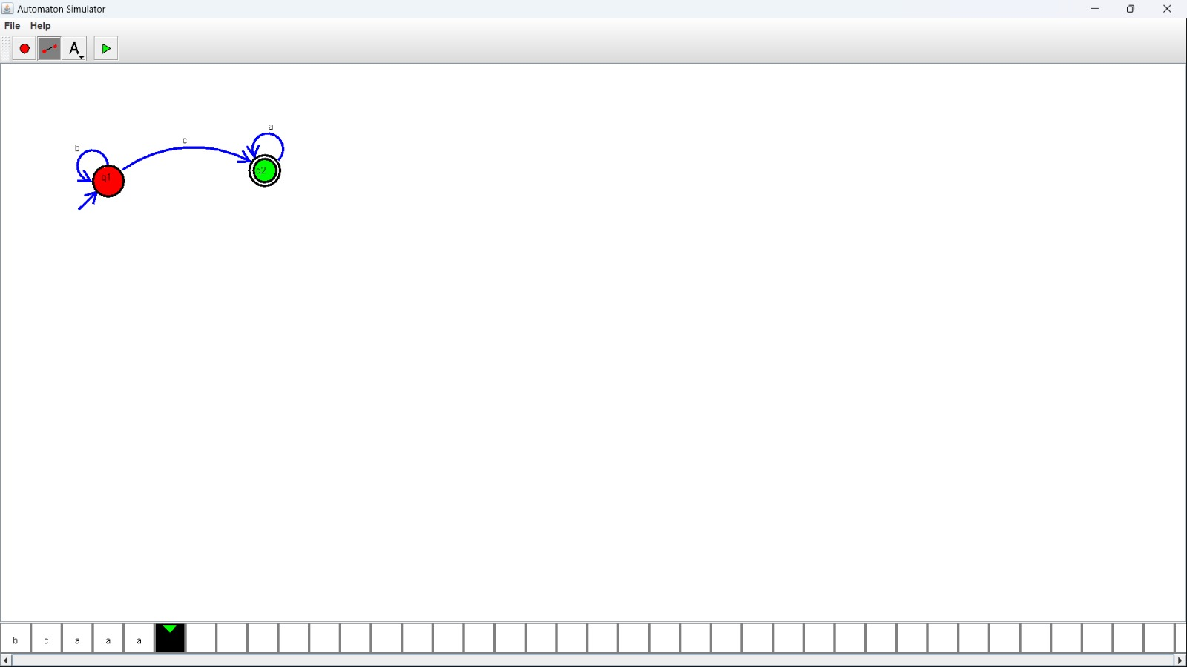

39 Design DFA using simulator to accept the string the end with abc over set {a,b,c) W= abbaababc

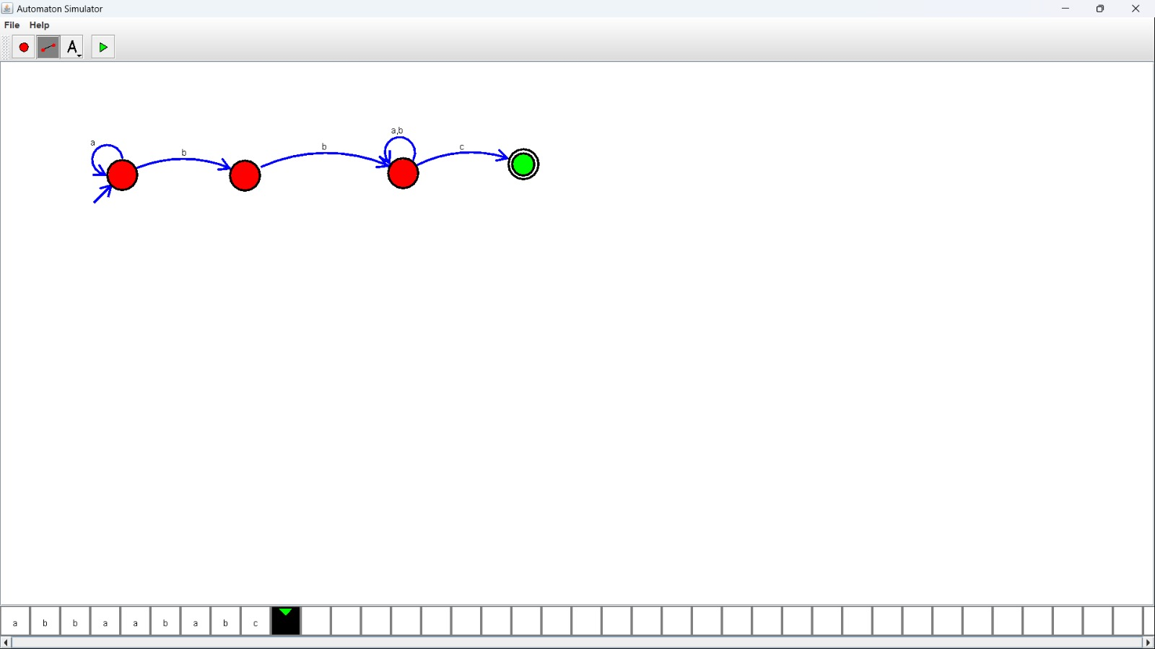

40. Design NFA to accept any number of b’s where input={a,b}.

